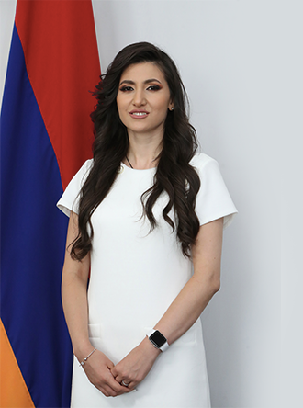

NELLY ARAKELYAN

PhD in Law, Senior Lecturer

e-mail: [N_araqelyan@mail.ru](mailto:N_araqelyan@mail.ru)

**Education**

2005-2009 - Bachelor's degree, Faculty of Law, Yerevan State University (YSU)  
2009-2011 - Master's degree, Faculty of Law, Yerevan State University (YSU)  
2015-2017 - Master's degree, International Human Rights Law, Charles University in Prague  
2011-2015 - Postgraduate program, Faculty of Law, Yerevan State University (YSU)

**Work Experience**

2011-2013 - Senior Specialist, Expert and Analytical Department, Constitutional Court of the Republic of Armenia  
2013-2019 - Chief Specialist, Expert and Analytical Department, Constitutional Court of the Republic of Armenia  
2019-present - Head of the Department of Issues Related to Judicial Proceedings, High Judicial Council

**Teaching Activity**  
2016-present - Senior Lecturer, Department of Legal Theory and Constitutional Law, Institute of Law and Politics, Russian-Armenian University  
2017-present - Faculty of Law, French University in Armenia

**Languages**  
Armenian – Native  
English – Excellent  
Russian – Excellent  
French – Good

**Առարկաներ**

History of Political and Legal Doctrines